Infosys Springboard Virtual Internship 7.0 Completion Report

Team Details : Intelligent farm operations platform with smart agro precision system Group 1 Batch 1 – Team C .Team Members are Mohit Radhod, Madhumitha G, Mungara Naga Venkata Rama Chandram, P Koushal, Partheepan Sree Kavya, Yamuna.

Batch Number : 1
Start date : 29/06/2026
Name : Mohit Rathod
Internship Duration: 8 Weeks

1. Project Title
Intelligent farm operations platform with smart agro precision system.

2. Project Objective
The main objective of the Intelligent farm operations platform with smart agro precision system is to develop a web-based system that helps farmers manage their farms and agricultural activities digitally. The system provides features for managing farms, crops, irrigation, fertilizers, user profiles, and agricultural reports.
The project aims to reduce manual record keeping, provide organized farm information, and make agricultural data easier to access and manage. It also provides separate access for Farmers and Administrators based on their roles.

3. Project description in detail
Intelligent farm operations platform with smart agro precision system is a full-stack web application developed for farm and agricultural management.
The project was developed using:
- Frontend: React.js
- Backend: Spring Boot
- Database: MySQL
- Authentication: JWT-based authentication
- API Testing: Postman
- UI Styling: Tailwind CSS
- Version Control: Git/GitHub
- Report Generation: PDF reports
The system allows users to register and log in securely. Farmers can manage their farms, crops, irrigation activities, and fertilizer records. Administrators can manage and view system-level information.
The dashboard displays dynamic information such as the number of farms and crops belonging to the logged-in user. The system uses user identification to ensure that farmers can access only their own farm-related data.
The project has real-world relevance because it provides a digital platform for maintaining agricultural records and monitoring farm activities in an organized manner.

4. Timeline Overview
Week | Activities Planned | Activities Completed
Week 1 | Project introduction, requirement analysis, technology selection,  And project planning | Studied the Intelligent farm operations platform with smart agro precision system requirements, modules, user roles, and overall project workflow
Week 2 | Develop basic backend structure | Set up Spring Boot backend, MySQL database and basic project structure
Week 3 | Develop landing page and  basic UI | Completed landing page, navigation, sidebar, top bar, and basic UI components
Week 4 | Implement authentication | Completed registration,  login, JWT authentication,  and Farmer/Admin role-based  access
Week 5 | Develop Farm and Crop CRUD operations | Completed Add, View, Update, and Delete operations for farms and crops and connected them with the database
Week 6 | Develop Irrigation and Fertilizer CRUD operations | Completed CRUD operations for irrigation and fertilizer management
Week 7 | API integration, API testing, report generation, and improvements | Integrated frontend with backend APIs, tested APIs using Postman, implemented report generation, dynamic dashboard cards, and error handling
Week 8 | Final testing, debugging, UI improvements, and documentation | Adding mail Notification Features .Completed final testing, fixed errors, improved responsive UI, verified modules, and prepared project documentation.

5a. Key Milestones
Milestone | Description | Date Achieved
Project Kickoff | Started the Intelligent farm operations platform with smart agro precision system project and analyzed the requirements | Week 1
Prototype/First Draft | Completed the initial frontend and backend structure | Week 2–3
Mid-Term Review | Completed authentication, dashboard, and major management modules | Week 4
Final Submission | Completed major features, testing, and integration | Week 8
Presentation | Prepared the application demonstration and project documentation | Week 8

5b. Project execution details
The project was developed using a frontend, backend, and database architecture.
First, the project requirements and database structure were analyzed. The MySQL database was designed to store users, farms, crops, irrigation records, fertilizer records, and reports.
The backend was developed using Spring Boot. REST APIs were created for authentication and management operations. JWT authentication was implemented to securely identify logged-in users. Role-based access was also implemented for Farmers and Administrators.
The frontend was developed using React.js. Pages such as the landing page, login, registration, dashboard, profile, farm management, crop management, irrigation, fertilizer, and reports were implemented.
The frontend communicates with the Spring Boot backend through REST APIs. Data is retrieved from and stored in the MySQL database.
The application was tested using Postman for backend API testing. Debugging was performed by checking API responses, backend console logs, database records, and frontend errors.
Finally, the application was integrated and improved with responsive UI, dynamic dashboard cards, tables, forms, navigation, error handling, and success messages.
Project Requirement Analysis
↓
System & Database Design
↓
Frontend & Backend Structure
↓
Database Implementation
↓
User Registration & Login
↓
JWT Authentication & Role Management
↓
Dashboard Implementation
↓
Farm Management
↓
Crop Management
↓
Irrigation Management
↓
Fertilizer Management
↓
Profile Management
↓
Report Generation
↓
Frontend–Backend Integration
↓
API Testing using Postman
↓
Debugging & Error Handling
↓
UI Improvements & Responsive Design
↓
Final Testing
↓
Project Completion & Documentation

6. Snapshots / Screenshots
FarmVerse Landing Page 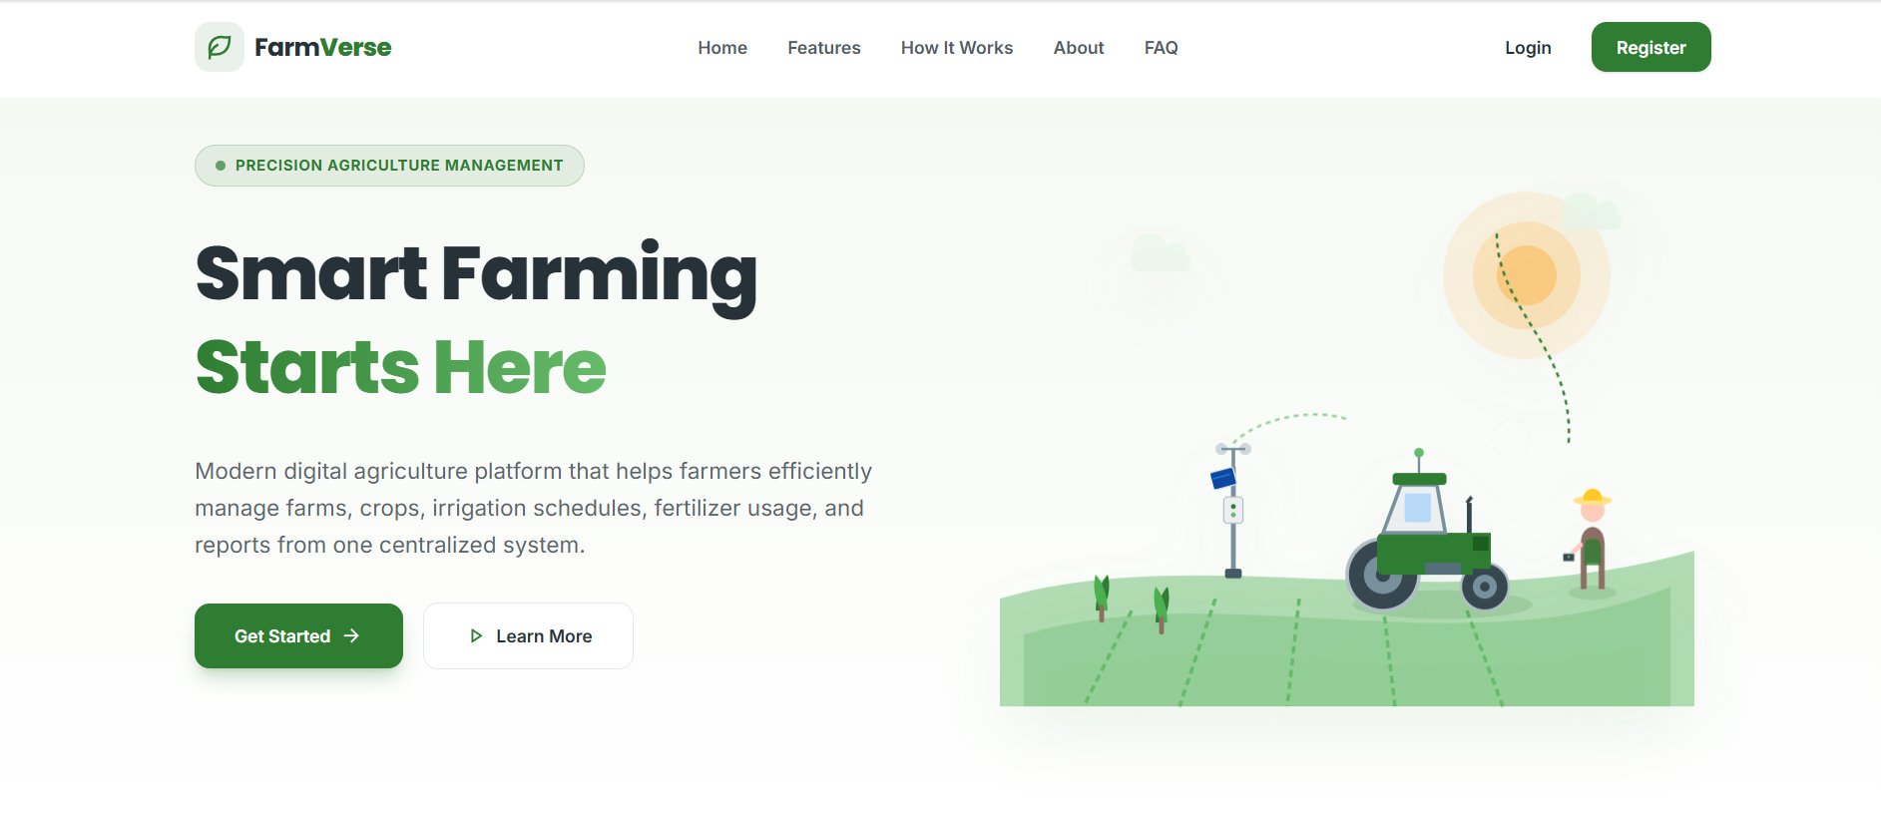
Authentication Flow
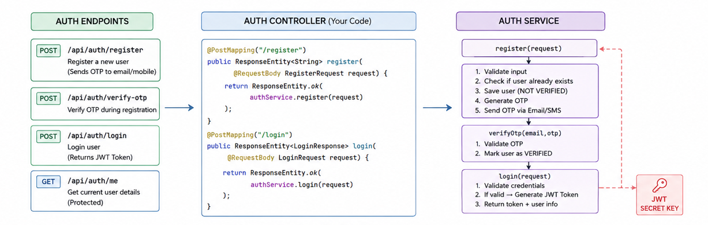
Farm CRUD Flow
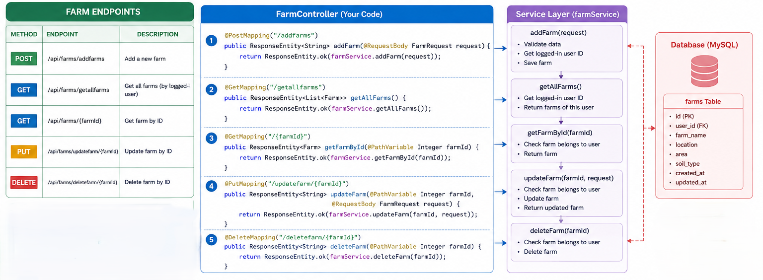
Add Farm Form
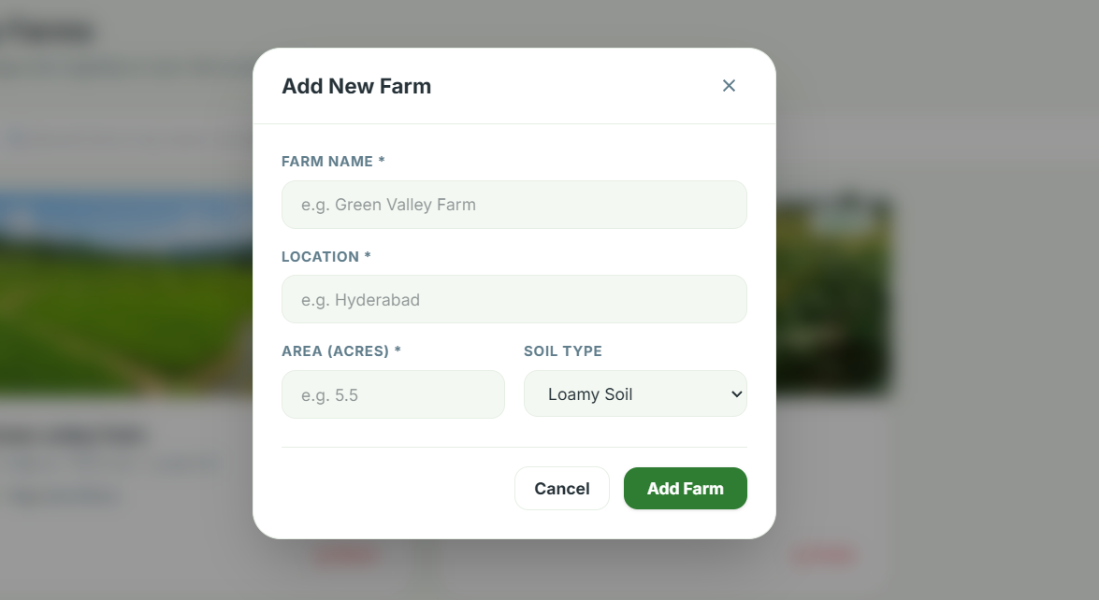
OTP verification -code snippet
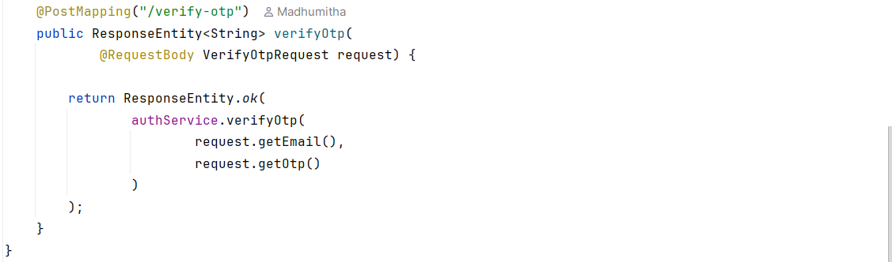
User Verification Status

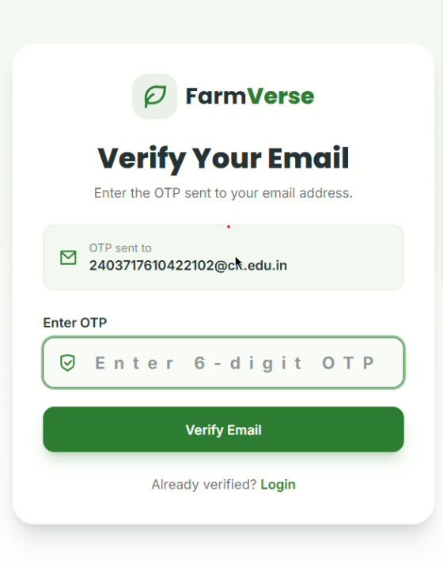
Email Notification – Code Implementation
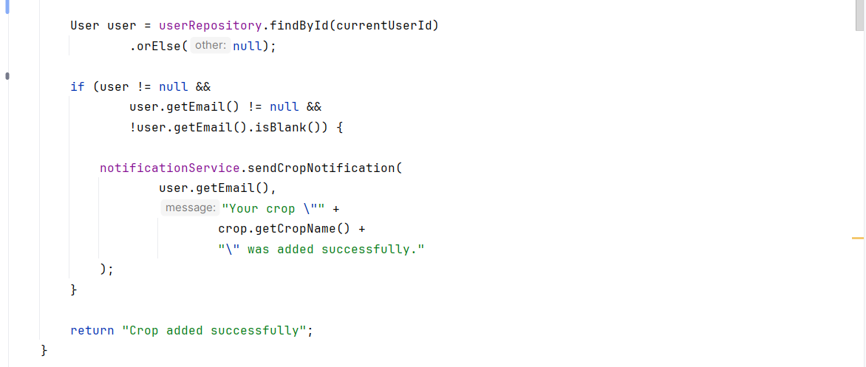
Email Notification
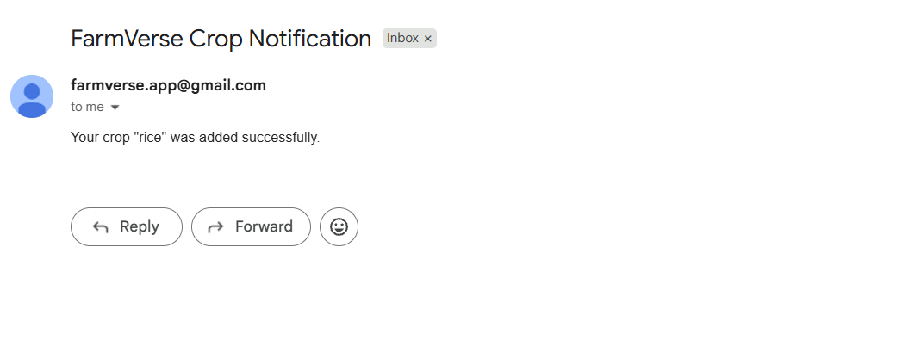

7. Challenges Faced
During the development of the project, several technical challenges were encountered.
Authentication and Authorization
Implementing JWT authentication and ensuring that only authenticated users could access protected pages was challenging.
Solution: JWT-based authentication and Spring Security were configured to protect backend endpoints.
User-Specific Data
The system needed to ensure that a farmer could access only their own farms and crops.
Solution: The logged-in user's ID was obtained from the authenticated user information and used when retrieving or adding farm-related data.
Frontend and Backend Integration
Connecting React components with Spring Boot REST APIs required proper request and response handling.
Solution: APIs were tested using Postman first and then integrated into the React frontend.
API Errors
Errors such as 400 Bad Request and 403 Forbidden occurred during authentication and API testing.
Solution: Backend logs, Postman responses, JWT tokens, and database records were checked to identify and resolve the problems.
Dynamic Dashboard
The dashboard needed to display information based on the currently logged-in user.
Solution: Dashboard data was retrieved from the backend and displayed dynamically instead of using fixed values.

8. Learnings & Skills Acquired
During the internship, the following technical and professional skills were developed:
Technical Skills
- React.js development
- Spring Boot development
- REST API development
- MySQL database management
- Spring Security
- JWT authentication
- CRUD operations
- API testing using Postman
- Git and GitHub
- Responsive UI development
- PDF report generation
- Frontend and backend integration
Professional Skills
- Problem solving
- Debugging
- Requirement analysis
- Project planning
- Documentation
- Time management
- Testing and validation
- Understanding real-world software development workflow

9. Testimonials from team
The internship provided valuable practical experience in developing a full-stack web application. The project helped in understanding how frontend, backend, database, authentication, and APIs work together in a real-world application.
The development of Intelligent farm operations platform with smart agro precision system improved technical knowledge as well as problem-solving and debugging skills. The experience also provided a better understanding of software development practices and project implementation.

10. Conclusion
Intelligent farm operations platform with smart agro precision system was successfully developed as a full-stack web application for managing agricultural activities.
The project includes user authentication, role-based access, dashboard, farm management, crop management, irrigation management, fertilizer management, profile management, and report generation.
The internship provided practical experience in React.js, Spring Boot, MySQL, REST APIs, JWT authentication, and software testing.
Overall, the project helped bridge the gap between academic knowledge and practical software development. It also provided valuable experience in developing, testing, debugging, and integrating a complete web application.

11. Acknowledgements
I would like to express my sincere gratitude to the organization for providing me with the opportunity to complete this internship and work on the Intelligent farm operations platform with smart agro precision system I would like to thank my mentor Vinay prashant and team members for their guidance, support, feedback, and encouragement throughout the project.
I am also grateful to my institution and faculty members for their continuous support and for providing the academic guidance required to successfully complete this internship.
The knowledge and practical experience gained during this internship will be valuable for my future academic and professional career.

